**Steps to setup Flutter in your windows machine**

1. Download Android Studio. Go to <https://developer.android.com/studio>

Click on download button.

Once its downloaded, install it by clicking ‘next’... Don’t change any default settings.

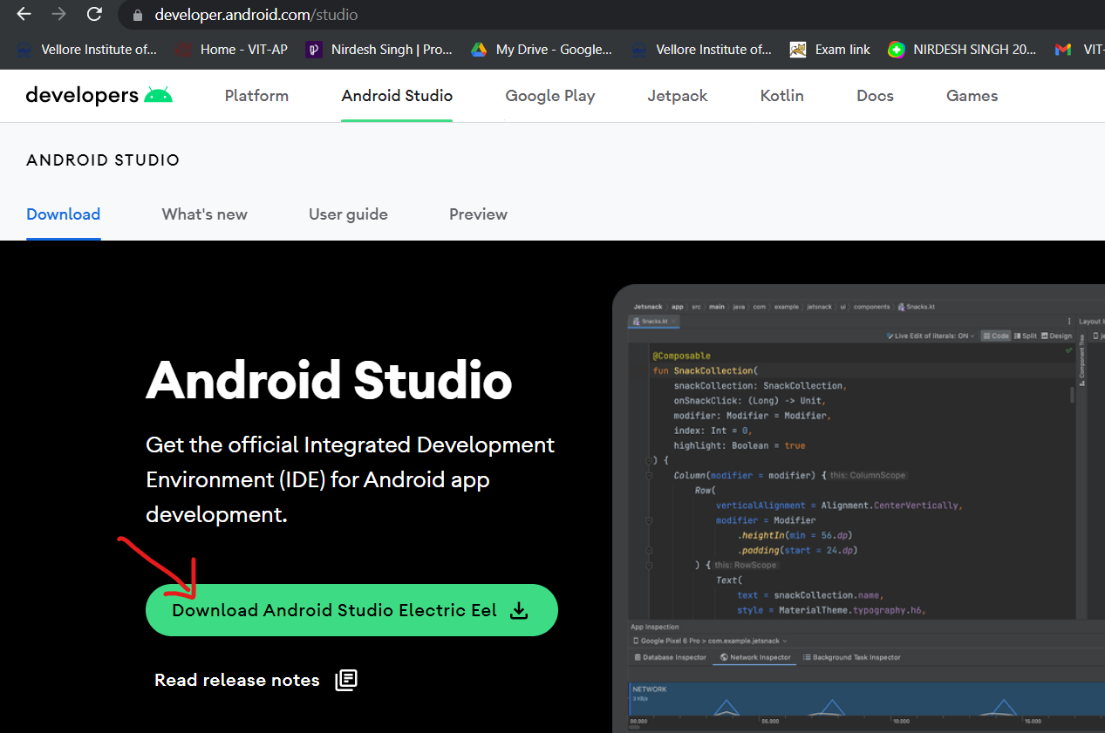

1. Next go to <https://git-scm.com/downloads>

And download Git for Windows by clicking the download button as shown below.



Once downloaded, install it.

To confirm if it is installed successfully, open cmd and type :

git --version

Hit Enter. It should show something like below.

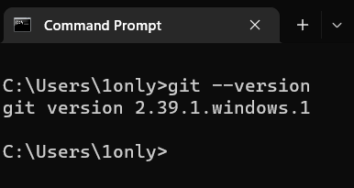

1. Now go to C drive

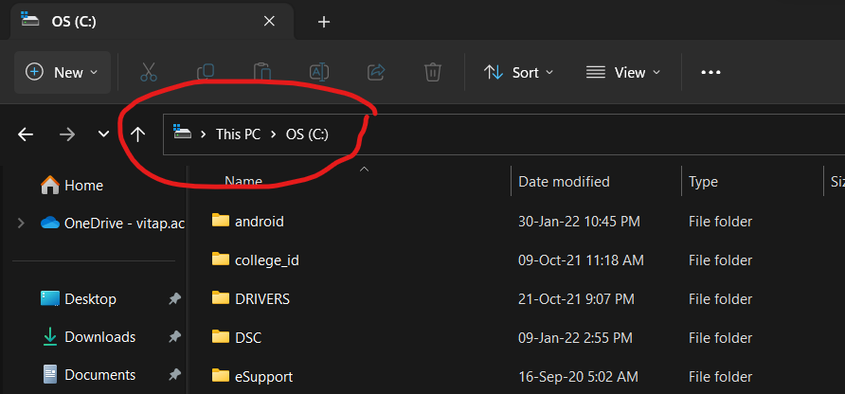

Here create a new folder ‘src’

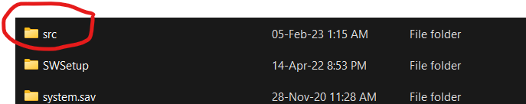

Open the ‘src’ folder and then open it in terminal by right-clicking and selecting the option ‘Open In Terminal’.

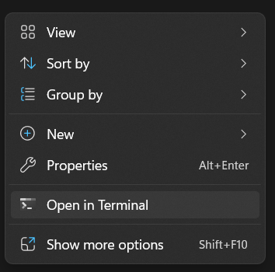

You should see something like this :

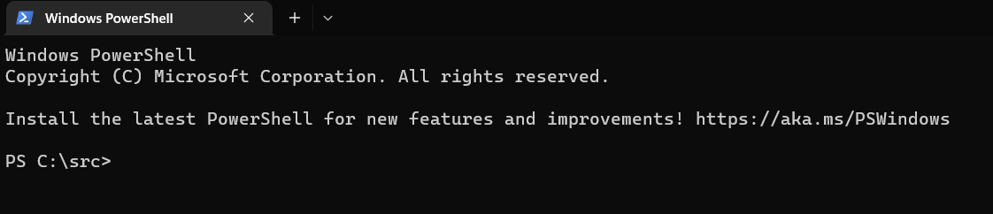

Now copy paste the following command and hit enter.

git clone https://github.com/flutter/flutter.git -b stable

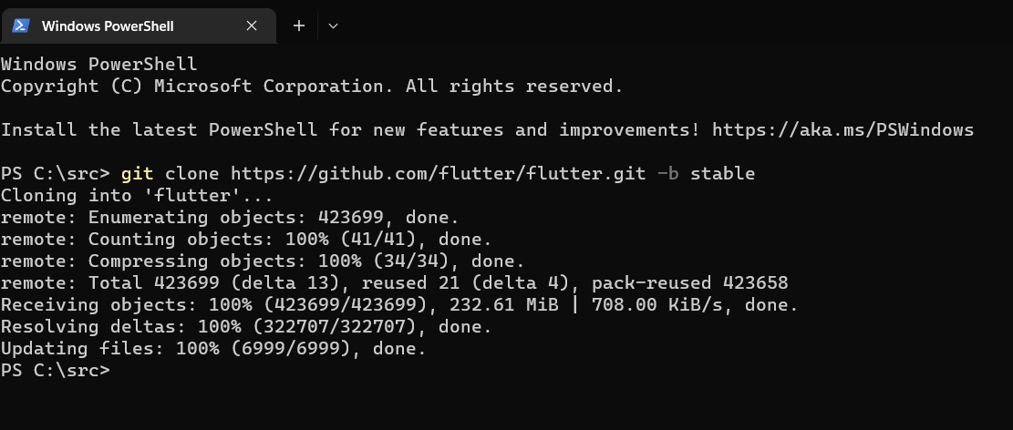

Let it get downloaded.

Once it’s downloaded you’ll see a flutter folder inside src folder.

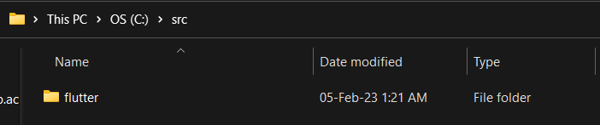

Now run the command :

flutter doctor

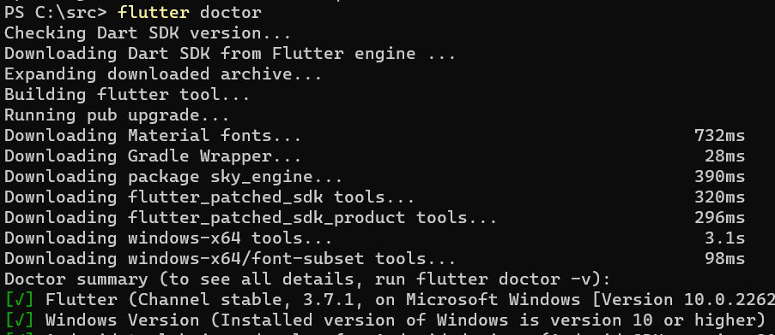

Let it download the Dart SDK for you.

1. Now we have to set its path.

In search type ‘envir’. ‘Edit the system environment variables’ should come up. Click on it.

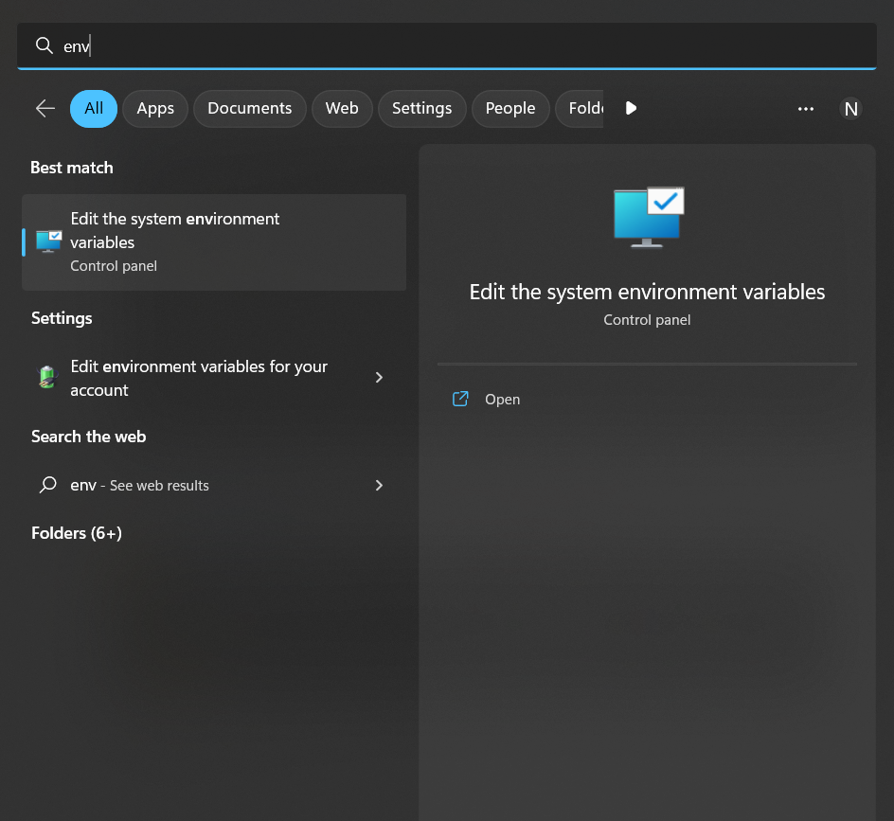

New window will pop-up. Click on ‘Environment Variables’ as shown below.

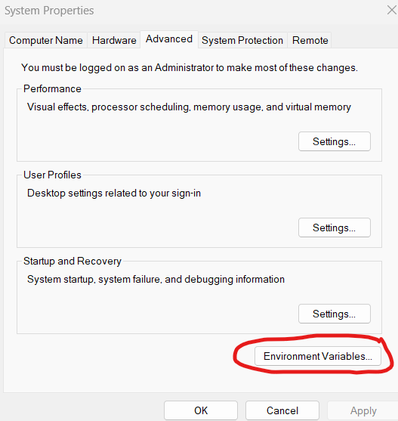

Again a new window will pop-up.

From there select ‘Path’ and then select ‘Edit’ as shown below.

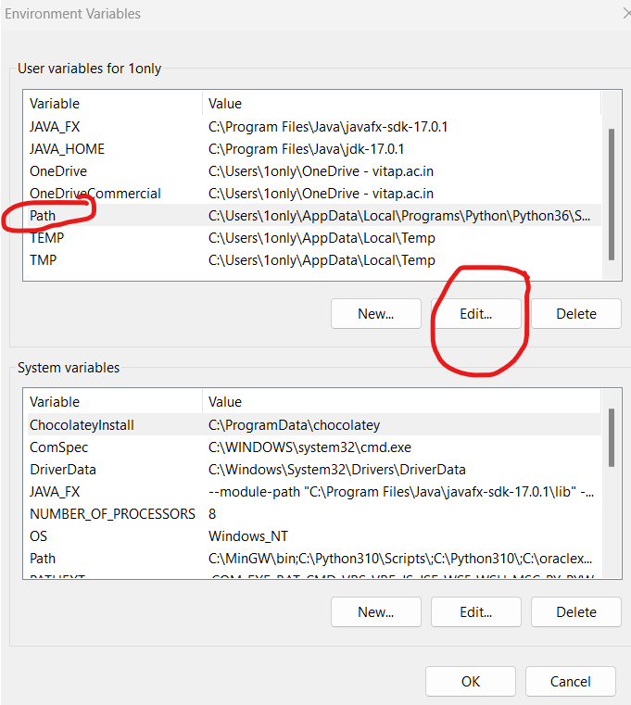

A new window will pop-up. Click on ‘New’ and add the following path :

C:\src\flutter\bin

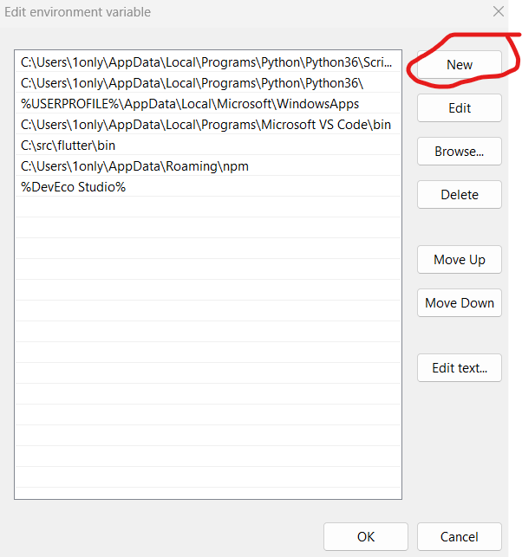

After adding it, click ‘ok’ and close all the windows.

To check if the path is set correctly, open cmd and run the command

flutter --version

You should get something like this :

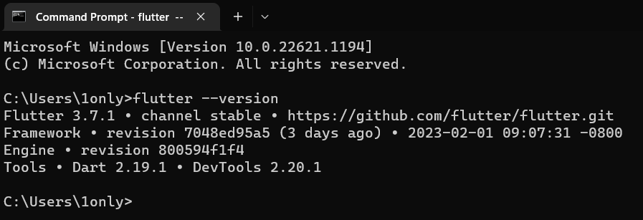

1. Now open Android Studio, go to Virtual Device Manager.

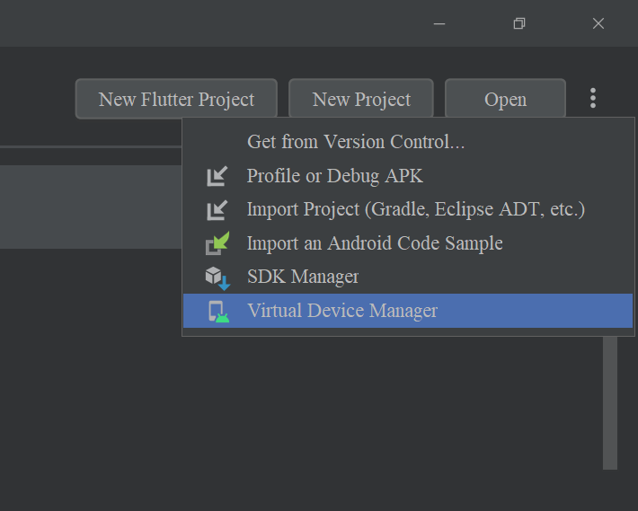

Now click on ‘Create device’ and follow the steps to create a virtual device. Once done you can close the android studio.

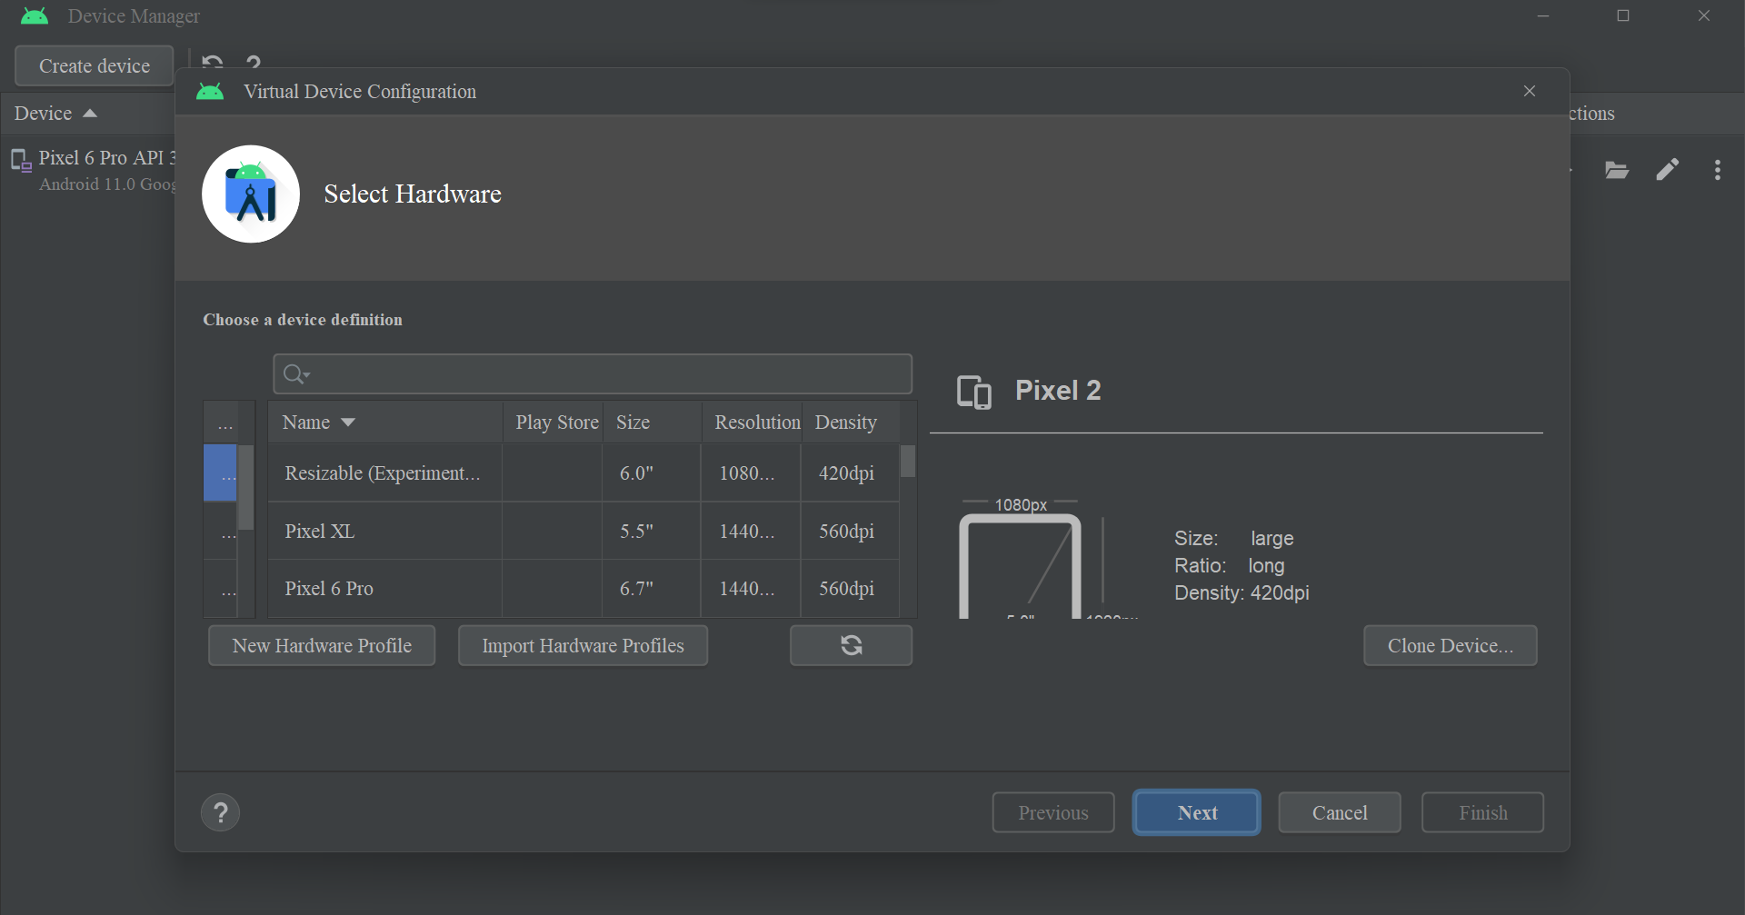

1. Now download and install VsCode.

In VsCode install the extensions ‘Flutter’ and ‘Dart’.

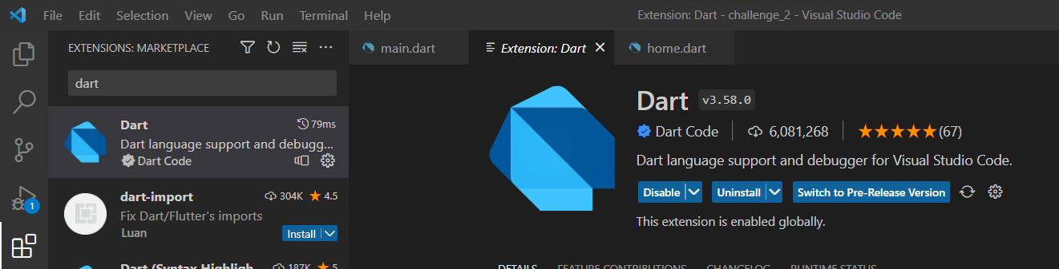

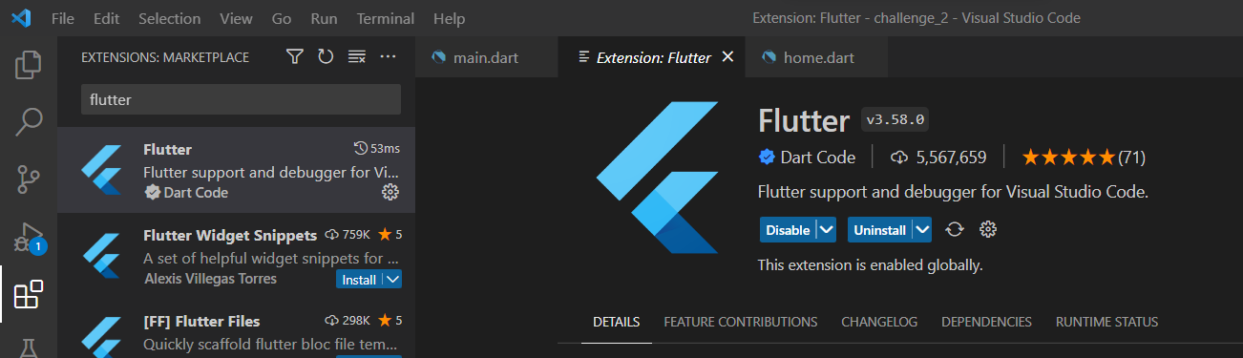

1. That’s it. You are good to go.